第1课时 两角差的余弦公式
课后训练巩固提升
一、A组
1.化简sin(x+y)sin(x-y)+cos(x+y)cos(x-y)的结果是( )
A.sin 2x B.cos 2y C.-cos 2x D.-cos 2y
解析:原式=cos(x+y)cos(x-y)+sin(x+y)·sin(x-y)=cos[(x+y)-(x-y)]=cos 2y.
答案:B
2.已知sin α=$\frac{2\sqrt{2}}{3}$,cos(α+β)=-$\frac{1}{3}$,且α,β∈$\left(0\text{,}\frac{π}{2}\right)$,则cos β等于( )
A.-1 B.$\frac{1}{2}$ C.-$\frac{1}{3}$ D.$\frac{7}{9}$
解析:因为sin α=$\frac{2\sqrt{2}}{3}$,cos(α+β)=-$\frac{1}{3}$,且α,β∈$\left(0\text{,}\frac{π}{2}\right)$,所以cos α=$\frac{1}{3}$,sin(α+β)=$\frac{2\sqrt{2}}{3}$.
所以cos β=cos[(α+β)-α]=cos(α+β)cos α+sin(α+β)·sin α=$\frac{7}{9}$,故选D.
答案:D
3.(多选题)已知函数f(x)=cos$\left(x\text{-}\frac{π}{4}\right)$cos x+sin$\left(\frac{π}{4}\text{-}x\right)$sin x,则下列结论正确的是( )
A.函数f(x)的最小正周期为π
B.函数f(x)的图象关于直线x=-$\frac{3π}{8}$对称
C.函数f(x)的图象关于直线x=$\frac{π}{8}$对称
D.函数f(x)的图象关于点$\left(\frac{π}{8}\text{,}0\right)$对称
解析:因为f(x)=cos$\left(x\text{-}\frac{π}{4}\right)$cos x+sin$\left(\frac{π}{4}\text{-}x\right)$sin x=cos$\left(\frac{π}{4}\text{-}x\right)$cos x+sin$\left(\frac{π}{4}\text{-}x\right)$sin x=cos$\left(2x\text{-}\frac{π}{4}\right)$,所以f(x)的最小正周期为π,故A正确.
由2x-$\frac{π}{4}$=kπ,k∈Z,得x=$\frac{kπ}{2}+\frac{π}{8}$,k∈Z,故f(x)的图象关于直线x=$\frac{kπ}{2}+\frac{π}{8}$,k∈Z对称,故B,C正确.
由2x-$\frac{π}{4}$=kπ+$\frac{π}{2}$,k∈Z,得x=$\frac{kπ}{2}+\frac{3π}{8}$,k∈Z,故f(x)的图象关于点$\left(\frac{kπ}{2}+\frac{3π}{8}\text{,}0\right)$,k∈Z对称,故D错误.
答案:ABC
4.已知cos$\left(θ+\frac{π}{6}\right)=\frac{5}{13}$,0<θ<$\frac{π}{3}$,则cos θ等于( )
A.$\frac{5\sqrt{3}+12}{26}$ B.$\frac{12\text{-}5\sqrt{3}}{13}$ C.$\frac{5+12\sqrt{3}}{26}$ D.$\frac{5+5\sqrt{3}}{13}$
解析:∵θ∈$\left(0\text{,}\frac{π}{3}\right)$,∴θ+$\frac{π}{6}∈\left(\frac{π}{6}\text{,}\frac{π}{2}\right)$.
∴sin$\left(θ+\frac{π}{6}\right)=\sqrt{1\text{-}cos^{2}\left(θ+\frac{π}{6}\right)}=\frac{12}{13}$,
∴cos θ=cos$\left[\left(θ+\frac{π}{6}\right)\text{-}\frac{π}{6}\right]$=cos$\left(θ+\frac{π}{6}\right)$cos$\frac{π}{6}$+sin$\left(θ+\frac{π}{6}\right)$sin$\frac{π}{6}=\frac{5}{13}×\frac{\sqrt{3}}{2}+\frac{12}{13}×\frac{1}{2}=\frac{5\sqrt{3}+12}{26}$.
答案:A
5.sin 162°sin 78°-cos 18°cos 102°= .
解析:sin 162°sin 78°-cos 18°cos 102°=sin 18°sin 78°+cos 18°cos 78°=cos(78°-18°)=cos 60°=$\frac{1}{2}$.
答案:$\frac{1}{2}$
6.已知钝角α,β满足sin α=$\frac{\sqrt{10}}{10}$,cos β=-$\frac{2\sqrt{5}}{5}$,则cos(α-β)= .
解析:因为α,β是钝角,
所以cos α=-$\frac{3\sqrt{10}}{10}$,sin β=$\frac{\sqrt{5}}{5}$.
所以cos(α-β)=cos αcos β+sin αsin β=-$\frac{3\sqrt{10}}{10}$×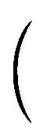-$\frac{2\sqrt{5}}{5}$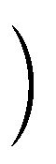+$\frac{\sqrt{10}}{10}×\frac{\sqrt{5}}{5}=\frac{7\sqrt{2}}{10}$.
答案:$\frac{7\sqrt{2}}{10}$
7.在平面直角坐标系Oxy中,角α与角β均以Ox为始边,它们的终边关于x轴对称.若sin α=$\frac{1}{4}$,则cos(α-β)= .
解析:∵角α与角β均以Ox为始边,它们的终边关于x轴对称,
∴sin α=-sin β=$\frac{1}{4}$,cos α=cos β=$\frac{\sqrt{15}}{4}$.
∴cos(α-β)=cos αcos β+sin αsin β=$\frac{\sqrt{15}}{4}×\frac{\sqrt{15}}{4}+\frac{1}{4}×\left(\text{-}\frac{1}{4}\right)=\frac{14}{16}=\frac{7}{8}$.
答案:$\frac{7}{8}$
8.已知角α的顶点为坐标原点,始边与x轴的非负半轴重合,终边经过点P(1,t),且点P到原点的距离为$\frac{\sqrt{6}}{2}$.
(1)求实数t的值;
(2)若α,β均为锐角,cos(α+β)=$\frac{3}{5}$,求cos β的值.
解:(1)由题意得1+t²=${\left(\frac{\sqrt{6}}{2}\right)}^{2}$,解得t=±$\frac{\sqrt{2}}{2}$.
(2)∵α为锐角,∴t=$\frac{\sqrt{2}}{2}$,即点P$\left(1\text{,}\frac{\sqrt{2}}{2}\right)$.
∴sin α=$\frac{y}{\sqrt{x^{2}+y^{2}}}=\frac{\sqrt{3}}{3}$.∴cos α=$\frac{\sqrt{6}}{3}$.
又α,β为锐角,∴α+β∈(0,π).
由cos(α+β)=$\frac{3}{5}$,
得sin(α+β)=$\sqrt{1\text{-}cos^{2}\text{(}α+β\text{)}}=\frac{4}{5}$.
∴cos β=cos[(α+β)-α]=cos(α+β)cos α+sin(α+β)sin α=$\frac{3}{5}×\frac{\sqrt{6}}{3}+\frac{4}{5}×\frac{\sqrt{3}}{3}=\frac{3\sqrt{6}+4\sqrt{3}}{15}$.
9.已知sin(3π-θ)=$\frac{\sqrt{5}}{2}$sin$\left(\frac{π}{2}+θ\right)$(θ∈R),求cos$\left(θ\text{-}\frac{π}{3}\right)$的值.
解:因为sin(3π-θ)=sin θ,sin$\left(\frac{π}{2}+θ\right)$=cos θ,
所以sin θ=$\frac{\sqrt{5}}{2}$cos θ.
因为sin²θ+cos²θ=1,
所以$\left\{\begin{matrix}sinθ=\frac{\sqrt{5}}{3}\text{,} \\ cosθ=\frac{2}{3}\end{matrix}\right.或\left\{\begin{matrix}sinθ=\text{-}\frac{\sqrt{5}}{3}\text{,} \\ cosθ=\text{-}\frac{2}{3}\text{.}\end{matrix}\right.$
所以cos$\left(θ\text{-}\frac{π}{3}\right)=\frac{1}{2}$cos θ+$\frac{\sqrt{3}}{2}$sin θ=±$\left(\frac{1}{3}+\frac{\sqrt{15}}{6}\right)$.
二、B组
1.已知sin(30°+α)=$\frac{3}{5}$,60°<α<150°,则cos α=( )
A.$\frac{3\text{-}4\sqrt{3}}{10}$ B.$\frac{3+4\sqrt{3}}{10}$
C.$\frac{3±4\sqrt{3}}{10}$ D.$\frac{4±3\sqrt{3}}{10}$
解析:∵60°<α<150°,∴90°<α+30°<180°.
∵sin(30°+α)=$\frac{3}{5}$,
∴cos(30°+α)=-$\sqrt{1\text{-}{\left(\frac{3}{5}\right)}^{2}}$=-$\frac{4}{5}$.
∴cos α=cos[(30°+α)-30°]=cos(30°+α)cos 30°+sin(30°+α)sin 30°=-$\frac{4}{5}×\frac{\sqrt{3}}{2}+\frac{3}{5}×\frac{1}{2}=\frac{3\text{-}4\sqrt{3}}{10}$,故选A.
答案:A
2.已知sin x+$\sqrt{3}$cos x=$\frac{6}{5}$,则cos$\left(\frac{π}{6}\text{-}x\right)$=( )
A.-$\frac{3}{5}$ B.$\frac{3}{5}$
C.-$\frac{4}{5}$ D.$\frac{4}{5}$
解析:∵sin x+$\sqrt{3}$cos x=2$\left(\frac{1}{2}sinx+\frac{\sqrt{3}}{2}cosx\right)$=2$\left(sin\frac{π}{6}sinx+cos\frac{π}{6}cosx\right)$=2cos$\left(\frac{π}{6}\text{-}x\right)=\frac{6}{5}$,
∴cos$\left(\frac{π}{6}\text{-}x\right)=\frac{3}{5}$.
答案:B
3.《周髀算经》中给出了弦图,所谓弦图是由四个全等的直角三角形和中间一个小正方形拼成一个大的正方形.若图中直角三角形两锐角分别为α,β,且小正方形与大正方形面积之比为9∶25,则cos(α-β)的值为( )
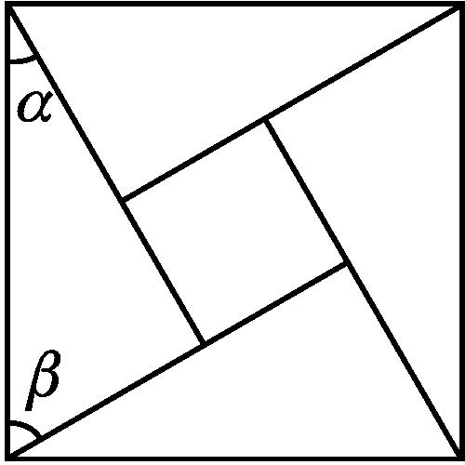
A.$\frac{5}{9}$ B.$\frac{4}{9}$ C.$\frac{9}{16}$ D.$\frac{16}{25}$
解析:设大的正方形的边长为1.
因为小正方形与大正方形面积之比为9∶25,
所以小正方形的边长为$\frac{3}{5}$.
所以cos α-sin α=$\frac{3}{5}$①,
sin β-cos β=$\frac{3}{5}$②.
因为α+β=$\frac{π}{2}$,所以cos α=sin β,sin α=cos β.
所以①×②可得$\frac{9}{25}$=cos αsin β+sin αcos β-cos αcos β-sin αsin β=sin²β+cos²β-cos(α-β)=1-cos(α-β),解得cos(α-β)=$\frac{16}{25}$.
答案:D
4.若sin α·sin β=1,则cos(α-β)的值为 .

解析:∵sin αsin β=1,|sin α|≤1,|sin β|≤1,
∴$\left\{\begin{matrix}sinα=\text{-}1\text{,} \\ sinβ=\text{-}1\end{matrix}\right.或\left\{\begin{matrix}sinα=1\text{,} \\ sinβ=1\text{.}\end{matrix}\right.$
∵cos²α+sin²α=1,∴cos α=0.
∴cos(α-β)=cos α·cos β+sin α·sin β=0+1=1.
答案:1
5.如图,在平面直角坐标系Oxy中,锐角α和钝角β的终边分别与单位圆相交于A,B两点.
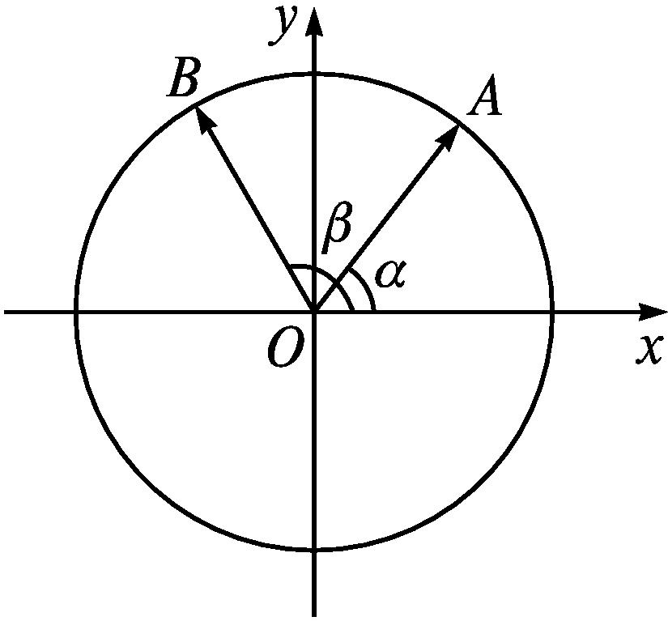
(1)如果A,B两点的纵坐标分别为$\frac{4}{5},\frac{12}{13}$,求cos α和sin β;
(2)在(1)的条件下,求cos(β-α)的值.
解:(1)∵OA=1,OB=1,且A,B两点的纵坐标分别为$\frac{4}{5},\frac{12}{13}$,∴sin α=$\frac{4}{5}$,sin β=$\frac{12}{13}$.
∴cos α=$\frac{3}{5}$.
(2)∵β为钝角,sin β=$\frac{12}{13}$,∴cos β=-$\frac{5}{13}$.
∴cos(β-α)=cos βcos α+sin βsin α=-$\frac{5}{13}×\frac{3}{5}+\frac{12}{13}×\frac{4}{5}=\frac{33}{65}$.
6.已知cos(α-β)=-$\frac{12}{13}$,cos(α+β)=$\frac{12}{13}$,且α-β∈$\left(\frac{π}{2}\text{,}π\right)$,α+β∈$\left(\frac{3π}{2}\text{,}2π\right)$,求角β的值.
解:∵α-β∈$\left(\frac{π}{2}\text{,}π\right)$,且cos(α-β)=-$\frac{12}{13}$,
∴sin(α-β)=$\frac{5}{13}$.
又α+β∈$\left(\frac{3π}{2}\text{,}2π\right)$,且cos(α+β)=$\frac{12}{13}$,
∴sin(α+β)=-$\frac{5}{13}$.
∴cos 2β=cos[(α+β)-(α-β)]
=cos(α+β)cos(α-β)+sin(α+β)sin(α-β)
=$\frac{12}{13}×\left(\text{-}\frac{12}{13}\right)+\left(\text{-}\frac{5}{13}\right)×\frac{5}{13}$=-1.
又α+β∈$\left(\frac{3π}{2}\text{,}2π\right)$,α-β∈$\left(\frac{π}{2}\text{,}π\right)$,
∴2β∈$\left(\frac{π}{2}\text{,}\frac{3π}{2}\right)$.
∴2β=π,即β=$\frac{π}{2}$.

